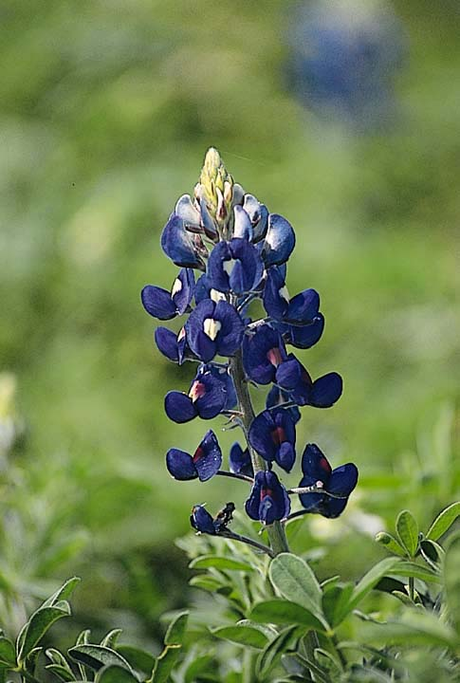
Bluebonnet Groundwater Conservation District

TOP WATER SMART TIPS

For Efficient Water Use In and Around the Home

WHY CONSERVE?

According to the Texas State Water Plan, Texas’ population is projected to increase 90% by 2050 and total municipal water demand is projected to increase 67% by 2050. Even with the 13.5% water savings projected from conservation in the next fifty years, water supply from existing sources will meet only 75% of the projected water demand by 2050. We must use our precious water resources more efficiently or we will have more frequent and more severe water shortages, especially during droughts and periods of peak demand (like hot Texas summers). Using water more efficiently will not only save money, but more importantly, will protect the quality of life of future generations. The cost of new or renovated water infrastructure, wastewater treatment and water supply is estimated to be $107 billion over the next fifty years. Each of us together can save billions of tax dollars by making our homes water smart. We must take on the responsibility of efficient water use now.

POSSIBLE SAVINGS WITH WATER CONSERVATION

Many cities offer substantial rebates for water efficient toilets, high efficiency washing machines, rainwater harvesting systems and water-wise landscaping. Water efficient showerheads and aerators for faucets cost only a few dollars and can cut your water usage in half with no reduction in performance. Leaking faucets and toilets can waste thousands of gallons of gallons of water monthly, and are inexpensive to fix. A few small changes in your water use habits can make a huge difference in water savings. In the summer, outdoor water use can account for 50% or more of total water use. With proper management, you can have a beautiful, healthy landscape and reduce your water use significantly. Practicing the tips outlined here could save up to 25,000 gallons per year for a family of four. This can amount to hundreds of dollars a year in water and wastewater costs!

TOP TEN CONSERVATION TIPS IN THE BATHROOM

- Replace your showerhead with a water efficient model. This saves as much as 6 gallons of water per minute!
- Recycle your old toilet and replace it with a water efficient toilet. This saves as much as 5 gallons per flush. Some cities have rebate programs that will pay for a new toilet, so what are you waiting for? If you can’t make yourself part with that old toilet, at least install a toilet displacement device (use a plastic bag or bottle filled with water to reduce the volume of water in the tank but still produce enough for flushing. Do not use bricks)
- Pay attention to those dripping sounds and fix the leak(s). Hard water ruins rubber parts over time. Periodically take the top off of your toilet tank and watch it flush. Do you notice any leaks? Yes? Replace that flapper or rubber washers. Don’t forget about those sneaky silent leaks. Add a few drops of food coloring or a dye table to the water in the tank. If the coloring appears in the bowl within a few minutes, the toilet has a leak that needs to be repaired.
- Don’t waste water when brushing your teeth. Shut off the water until it is time to rinse.
- Don’t waste water while shaving! Fill the sink with hot water instead of letting the water run continuously. Don’t shave in the shower.
- Never use the toilet to dispose of trash.
- Get in the shower right away after the water becomes hot enough!
- Take short showers and wash hands using only as much water flow as you really need!
- Take a shower instead of taking a bath. Showers with water efficient show heads often use less water than taking a bath.
- Turn off the water while you are shampooing your hair.

TOP TEN CONSERVATION TIPS IN THE KITCHEN

- Never run the dishwasher without a full load! This practice will save water, energy, detergent and money. If your dishes are not very dirty, use the short wash cycle. If you buy a new machine, ask for a water saving model.
- Don’t leave the water running when you aren’t using it.
- Install faucet aerators. You’ll never notice the difference and you’ll cut your sink water consumption in half. Also, don’t ignore leaky faucets. They waste lots of water!
- Your drinking water will be much more refreshingly cool if you keep a container of it in the refrigerator! Running water from the tap until it is cool is wasteful.
- Dry scrape dishes instead of rinsing. Your dishwasher will take care of the rest.
- Garbage disposals can waste water unnecessarily! Use them only for really messy stuff, not a heap of peels that can easily be dumped in the garbage.
- Soak pans rather than scrubbing them while the water is running!
- Rinse your vegetables in a pan of cold water! It doesn’t take gallons of water to get the dirt off!
- Steam your vegetables instead of boiling them in a pot of water.
- Don’t over-water your house plants! More plants die from over-watering than from being on the dry side. Collect rainwater or recycle water from fish tanks to water your plants.

ADDITIONAL CONSERVATION TIPS FOR DOING LAUNDRY

- Wash only full loads. Conventional washing machines use up to 55 gallons of water per load! If you must wash partial loads, match the load setting on the washing machine with the amount of laundry to be washed.
- Buy a high efficiency washer. They use at least 40% less water and energy as conventional washers. Also, they are gentler on clothes, extract more water during the spin cycle, and use less detergent! Some cities offer rebates on water efficient models.
- If your clothes are not heavily soiled, use the short was cycle.

ADDITIONAL CONSERVATION TIPS FOR APPLIANCES AND PLUMBING

- Be a water leak sleuth! Don’t ignore leaking faucets, they are usually easy and inexpensive to repair. Turn off the valve under the sink until you get around to repairing the leak. A slow drip can waste as much as 170 gallons of water each day! Periodically turn of all water-using appliances, note the reading on your water meter and check it again after 20 minutes to find hidden leaks.
- Insulate hot water pipes. You won’t waste water waiting for it to get hot and you will save energy too.!
- Buy water and energy efficient appliances!

TOP TEN OUTDOOR CONSERVATION TIPS

- Don’t over-water your lawn! One inch of water per week! One inch of water per week in the summer will keep most common grasses healthy. To determine how long you should run your sprinklers, place straight edged cans at different distances away from the sprinkler and time how long it takes to fill an average of one inch of water in each can.
- Don’t abuse the benefits of an automatic sprinkler system by wasting large amounts of water! Set it to provide thorough, but infrequent watering. Check sprinkler heads regularly to make sure they are working properly. Install rain shut-off devices and adjust sprinklers to eliminate coverage on pavement.
- Prevent evaporation of water! Water lawns early in the morning or in late evening during the hotter summer months. Never water on windy days. Use drip irrigation systems for bedded plants, trees or shrubs and use low angle sprinklers for lawns. Cover pools and spas. This can save the equivalent of your pool volume each year!
- Plant water-wise, well-adapted and/or native shrubs, trees and grass! Choose plants that are drought-tolerant, heat-tolerant, and are tolerant of the minimum winter temperatures in your area. In odd-shaped areas, use drought-tolerant ground cover instead of grass. Many cities provide lists of water-wise plants and offer landscaping rebates.
- Harvest the rain! Buy a rain barrel or a cistern and collect the water from your gutters to water your plants.
- Use your water efficiently. Don’t waste water by cleaning the streets or sidewalks with it, use a broom. For plants that need more water, use a hose or watering can.
- Don’t scalp lawns when mowing during hot weather. Taller grass holds moisture better! Keep grass 3 inches tall during the summer and don’t cut more than 1/3 of its length at one time. Leave lawn clippings on the lawn instead of bagging.
- Use lots of mulch around your shrubs and trees! It will retain moisture, reduce nun-off, moderate soil temperatures and help with weed control.
- Do not over-fertilize! Contact your county Texas Cooperative Extension office or your local water-wise nursery professional to determine what nutrients your soil needs. If you apply fertilizer only in the spring and fall, your grass will be healthy, use less water and need mowing less frequently.
- Use a car wash that recycles water! If you are washing your car at home, use a bucket of soapy water and use a hose nozzle that shuts off the water while you scrub!

Adopted from a publication by the Texas Water Development Board, P.O. Box 13231, Capitol Station, Austin, Texas 78711-3231

